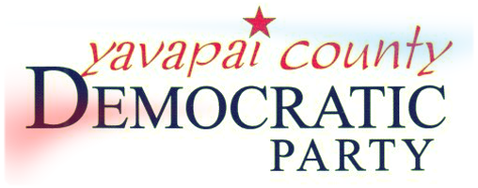 | Action Network (YCAN)  Interest Survey

Please print and complete this survey to indicate your interest and potential involvement in our effort to promote grassroots action to hold our elected officials accountable and to defeat agendas which would negatively impact us and our fellow citizens. Send it to YCAN at the address below. Do it today!

NAME:
EMAIL ADDRESS:
PHONE:
MAILING ADDRESS:

Primary Areas of Interest/Concern:

How are you willing to help? (Pick your top 4.)

□ Maintain database of information
□ Keep fellow activists informed
□ Attend issue-oriented meetings
□ Attend town halls
□ Phone calls to elected officials
□ Emails to elected officials
□ Letters to elected officials
□ Coordinate meetings/calendar
□ Visit offices of elected officials
□ Monitor issues/voting records
□ Write letters to the editor
□ Speak at gatherings
□ Speak at public forums
□ Identify potential candidates
□ Establish personal contact w/officials
□ Participate in network activities
□ Lead activities
□ Regularly attend meetings of bodies
□ Webpage/social media creation/update

□ Other_________________________________________________________________________________________________________
What skills can you bring to the network?

Please list any connections you have to useful information sources (persons, groups).
Please return to:  Yavapai YCAN  P. O. Box 1644  Prescott, AZ 86302 - or in person  1555 Iron Springs Road, Suite 1  Prescott, AZ  928-541-0413 | For more info:  LaBeth Pondish  928-775-0393 (H)  928-848-1639 (Cell)  labethaz1@msn.com

We welcome your suggestions. Please use the back of the page.

